**Changing Variables – Planning an Experiment**  Name: __________________

When someone wants to do an experiment they must make sure that they only test **A SINGLE** variable - The variable they change is called the _______________________ variable. (1)

Angela ran an experiment on bouncing balls and recorded the results

|  |  |  |  |
| --- | --- | --- | --- |
| Ball | Surface | Drop height (cm) | Bounce Height (cm) |
| Tennis | Sand | 25 | 1 |
| Squash | Concrete | 200 | 25 |
| Golf | Gravel | 150 | 8 |
| Volley Ball | Grass | 60 | 20 |

On the basis of her results, Angela claimed that squash balls bounced higher than tennis balls.

State the DEPENDENT variable that Angela tested (factor you measured) ? (1)

_________________________________________________________________

Identify how many variables Angela changed during the experiment (3)

_______________________________________ ____________________________________

_______________________________________ ____________________________________

_______________________________________ ____________________________________

_______________________________________ ____________________________________

Assess/ decide whether the experiment was a fair test _____________________________________

Why?______________________________________________________________________________________________________________________________________________________________________________________________________________________________________________(2)

Do you agree with Angela’s conclusion about squash balls? ____________________________

Give reasons for your answer__________________________________________________________

________________________________________________________________________________(1)

What could Angela do to fix her experiment: _____________________________________________

__________________________________________________________________________________________________________________________________________________________________(2)

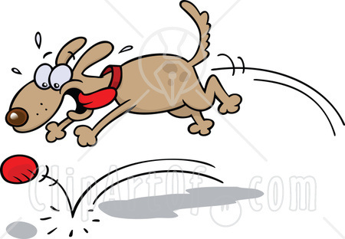**Designing your own Experiment** Your task is to design an experiment that will test ONE variable that is likely to affect the bounce height of a ball.

**Title:** ________________________________

**Aim:** _______________________________________________________________(1)

Independent (changed) variable: _________________________________________(1)

Dependent (measured) variable: _________________________________________(1)

Controlled variables: (things to keep the same (2)

_________________________________________________

__________________________________________________ __________________________________________________ __________________________________________________ __________________________________________________ __________________________________________________

Equipment I will use in this experiment: (1)

__________________________________________________ __________________________________________________ __________________________________________________ __________________________________________________

Method: (steps I will take in this experiment) (2)

__________________________________________________________________________ __________________________________________________________________________ __________________________________________________________________________ __________________________________________________________________________ __________________________________________________________________________ __________________________________________________________________________ __________________________________________________________________________ __________________________________________________________________________

Remember to repeat your experiment about 3 times to check for accuracy

Diagram: (2)

Results: (draw a table to record your results) (4)

Conclusion: (what I have found in the experiment)

I tested ___________________________________________________________________  
__________________________________________________________________________

_______________________________________________________________________(1)

Our group found out these results (2)

__________________________________________________________________________

__________________________________________________________________________

__________________________________________________________________________

Ways we could improve this experiment (2)

__________________________________________________________________________

__________________________________________________________________________

__________________________________________________________________________

Total: __________ / 29